LAMPIRAN

Isi lembar checklist sesuai dengan keterangan dibawah ini! 1 = Lengkap
0 = Tidak Lengkap
Lampiran 1 Lembar Check list

No | No RM | Identifikasi |  |  | Pelaporan |  |  |  |  | Autentifikasi |  |  |  | Pendokumentasian
No | No RM | No Rm | Nama | Tanggal Lahir | Anamnesis | Diagnosis | Pemeriksaan Fisik | Tindakan | Tanggal & Jam | Nama Dokter | Ttd Dokter | Nama Pasien | Ttd Pasien | Keterbacaan | Pembenaran
Total

Rata-Rata
Persentase

Lampiran 2 Hasil Olah Data

No | No RM | Identifikasi |  |  | Pelaporan |  |  |  |  | Autentifikasi |  |  |  | Pendokumentasian
No | No RM | No Rm | Nama | Tanggal Lahir | Anamnesis | Diagnosis | Pemeriksaan Fisik | Tindakan | Tanggal & Jam | Nama Dokter | Ttd Dokter | Nama Pasien | Ttd Pasien | Keterbacaan | Pembenaran
1 | 014100 | 1 | 1 | 1 | 1 | 1 | 1 | 1 | 1 | 1 | 1 | 0 | 1 | 1 | 1
2 | 014101 | 1 | 1 | 1 | 1 | 1 | 1 | 1 | 1 | 0 | 0 | 0 | 1 | 1 | 1
3 | 008737 | 1 | 1 | 1 | 1 | 1 | 1 | 1 | 1 | 1 | 1 | 0 | 1 | 1 | 1
4 | 014103 | 1 | 1 | 1 | 1 | 1 | 1 | 1 | 1 | 1 | 1 | 1 | 1 | 1 | 1
5 | 014106 | 1 | 1 | 1 | 1 | 1 | 1 | 1 | 1 | 1 | 1 | 0 | 1 | 1 | 1
6 | 013786 | 1 | 1 | 1 | 1 | 1 | 1 | 1 | 1 | 1 | 1 | 1 | 1 | 1 | 1
7 | 011534 | 1 | 1 | 1 | 1 | 1 | 1 | 1 | 1 | 1 | 1 | 0 | 1 | 1 | 1
8 | 011567 | 1 | 1 | 1 | 1 | 1 | 1 | 1 | 1 | 1 | 1 | 0 | 1 | 1 | 1
9 | 011727 | 1 | 1 | 1 | 1 | 1 | 1 | 1 | 1 | 1 | 1 | 0 | 0 | 1 | 1
10 | 014056 | 1 | 1 | 1 | 1 | 1 | 1 | 1 | 1 | 1 | 1 | 1 | 1 | 1 | 1
11 | 014129 | 1 | 1 | 1 | 1 | 1 | 1 | 1 | 1 | 1 | 1 | 0 | 1 | 1 | 1
12 | 010741 | 1 | 1 | 1 | 1 | 1 | 1 | 1 | 1 | 1 | 1 | 1 | 1 | 1 | 1
13 | 015145 | 1 | 1 | 1 | 1 | 1 | 1 | 0 | 0 | 1 | 1 | 0 | 1 | 1 | 1
14 | 015141 | 1 | 1 | 1 | 1 | 1 | 1 | 1 | 0 | 1 | 1 | 0 | 1 | 1 | 1
15 | 014903 | 1 | 1 | 1 | 1 | 1 | 1 | 1 | 1 | 1 | 1 | 1 | 1 | 1 | 1
16 | 013659 | 1 | 1 | 1 | 1 | 1 | 1 | 1 | 1 | 1 | 1 | 0 | 1 | 1 | 1
17 | 013060 | 1 | 1 | 1 | 1 | 1 | 1 | 1 | 1 | 1 | 1 | 1 | 1 | 1 | 1
18 | 009487 | 1 | 1 | 1 | 1 | 1 | 1 | 1 | 1 | 1 | 1 | 0 | 1 | 1 | 1
19 | 009036 | 1 | 1 | 1 | 1 | 1 | 0 | 0 | 1 | 1 | 1 | 1 | 1 | 1 | 1
20 | 019958 | 1 | 1 | 1 | 1 | 1 | 1 | 0 | 1 | 1 | 1 | 1 | 1 | 1 | 1
21 | 010092 | 1 | 1 | 1 | 1 | 1 | 1 | 1 | 0 | 1 | 1 | 0 | 0 | 1 | 1

22 | 012858 | 1 | 1 | 1 | 1 | 1 | 1 | 1 | 1 | 1 | 1 | 1 | 1 | 1 | 1
23 | 014851 | 1 | 1 | 1 | 1 | 1 | 0 | 1 | 1 | 1 | 1 | 0 | 0 | 1 | 1
24 | 015384 | 1 | 1 | 1 | 1 | 1 | 0 | 1 | 1 | 1 | 1 | 0 | 1 | 1 | 1
25 | 015556 | 1 | 1 | 1 | 1 | 1 | 1 | 0 | 1 | 1 | 1 | 0 | 1 | 1 | 1
26 | 015553 | 1 | 1 | 1 | 1 | 1 | 1 | 0 | 1 | 1 | 1 | 1 | 1 | 1 | 1
27 | 015547 | 1 | 1 | 1 | 1 | 1 | 1 | 1 | 1 | 1 | 1 | 1 | 1 | 1 | 1
28 | 013746 | 1 | 1 | 1 | 1 | 1 | 0 | 1 | 1 | 1 | 1 | 1 | 1 | 1 | 1
29 | 015531 | 1 | 1 | 1 | 1 | 1 | 0 | 0 | 1 | 1 | 1 | 1 | 1 | 1 | 1
30 | 013880 | 1 | 1 | 1 | 1 | 1 | 1 | 1 | 1 | 1 | 1 | 0 | 0 | 1 | 1
31 | 011955 | 1 | 1 | 1 | 1 | 1 | 1 | 1 | 1 | 1 | 1 | 1 | 1 | 1 | 1
32 | 015441 | 1 | 1 | 1 | 1 | 1 | 0 | 1 | 1 | 1 | 1 | 0 | 1 | 1 | 1
33 | 015514 | 1 | 1 | 1 | 1 | 1 | 0 | 1 | 1 | 0 | 1 | 0 | 1 | 1 | 1
34 | 015467 | 1 | 1 | 1 | 1 | 1 | 0 | 1 | 1 | 1 | 1 | 1 | 1 | 1 | 1
35 | 015481 | 1 | 1 | 1 | 1 | 1 | 1 | 1 | 0 | 1 | 1 | 1 | 1 | 1 | 1
36 | 014795 | 1 | 1 | 1 | 1 | 1 | 1 | 1 | 1 | 1 | 1 | 1 | 1 | 1 | 1
37 | 014923 | 1 | 1 | 1 | 1 | 1 | 1 | 1 | 1 | 1 | 1 | 1 | 1 | 1 | 1
38 | 011388 | 1 | 1 | 1 | 1 | 1 | 0 | 0 | 1 | 1 | 1 | 1 | 1 | 1 | 1
39 | 018912 | 1 | 1 | 1 | 1 | 1 | 0 | 0 | 1 | 1 | 1 | 0 | 1 | 1 | 1
40 | 015906 | 1 | 1 | 1 | 1 | 1 | 1 | 0 | 1 | 1 | 1 | 0 | 1 | 1 | 1
41 | 015911 | 1 | 1 | 1 | 1 | 1 | 1 | 1 | 1 | 1 | 1 | 0 | 1 | 1 | 1
42 | 015909 | 1 | 1 | 1 | 1 | 1 | 1 | 0 | 1 | 1 | 1 | 1 | 1 | 1 | 1
43 | 015907 | 1 | 1 | 1 | 1 | 1 | 1 | 0 | 1 | 1 | 1 | 0 | 1 | 1 | 1
44 | 008888 | 1 | 1 | 1 | 1 | 1 | 1 | 0 | 1 | 1 | 1 | 1 | 1 | 1 | 1
45 | 014289 | 1 | 1 | 1 | 1 | 1 | 1 | 1 | 1 | 1 | 1 | 0 | 1 | 1 | 1
46 | 015836 | 1 | 1 | 1 | 1 | 1 | 1 | 0 | 1 | 1 | 1 | 1 | 1 | 1 | 1
47 | 014541 | 1 | 1 | 1 | 1 | 1 | 1 | 1 | 1 | 1 | 1 | 1 | 1 | 1 | 1

48 | 015051 | 1 | 1 | 1 | 1 | 1 | 1 | 1 | 1 | 1 | 1 | 1 | 1 | 1 | 1
49 | 013769 | 1 | 1 | 1 | 1 | 1 | 1 | 1 | 1 | 1 | 1 | 1 | 1 | 1 | 1
50 | 001291 | 1 | 1 | 1 | 1 | 1 | 1 | 1 | 1 | 1 | 1 | 1 | 1 | 1 | 1
51 | 016429 | 1 | 1 | 1 | 1 | 1 | 1 | 1 | 1 | 1 | 1 | 1 | 1 | 1 | 1
52 | 016427 | 1 | 1 | 1 | 1 | 1 | 1 | 0 | 1 | 1 | 1 | 1 | 1 | 1 | 1
53 | 016429 | 1 | 1 | 1 | 1 | 1 | 1 | 0 | 1 | 1 | 1 | 0 | 0 | 1 | 1
54 | 016420 | 1 | 1 | 1 | 1 | 1 | 1 | 0 | 1 | 0 | 1 | 0 | 1 | 1 | 1
55 | 016204 | 1 | 1 | 1 | 1 | 1 | 1 | 1 | 1 | 1 | 1 | 1 | 1 | 1 | 1
56 | 013901 | 1 | 1 | 1 | 1 | 1 | 1 | 1 | 1 | 0 | 0 | 1 | 1 | 1 | 1
57 | 013879 | 1 | 1 | 1 | 1 | 1 | 1 | 1 | 1 | 1 | 1 | 1 | 1 | 1 | 1
58 | 016152 | 1 | 1 | 1 | 1 | 1 | 1 | 1 | 1 | 0 | 1 | 1 | 1 | 1 | 1
59 | 015622 | 1 | 1 | 1 | 1 | 1 | 1 | 1 | 1 | 0 | 1 | 0 | 1 | 1 | 1
60 | 009077 | 1 | 1 | 1 | 1 | 1 | 1 | 1 | 1 | 1 | 1 | 0 | 1 | 1 | 1
61 | 017403 | 1 | 1 | 1 | 1 | 1 | 1 | 0 | 1 | 0 | 1 | 0 | 0 | 1 | 1
62 | 017404 | 1 | 1 | 1 | 1 | 1 | 1 | 0 | 0 | 1 | 1 | 0 | 1 | 1 | 1
63 | 017376 | 1 | 1 | 1 | 1 | 1 | 1 | 1 | 1 | 1 | 1 | 0 | 1 | 1 | 1
64 | 015749 | 1 | 1 | 1 | 1 | 1 | 1 | 1 | 1 | 1 | 1 | 0 | 0 | 1 | 1
65 | 014501 | 1 | 1 | 1 | 1 | 1 | 1 | 1 | 1 | 1 | 1 | 0 | 1 | 1 | 1
66 | 017369 | 1 | 1 | 1 | 1 | 1 | 1 | 1 | 1 | 0 | 1 | 0 | 1 | 1 | 1
Total |  | 66 | 66 | 66 | 66 | 66 | 56 | 48 | 61 | 58 | 64 | 32 | 59 | 66 | 66
Rata-Rata |  | 100% | 100% | 100% | 100% | 100% | 84,8% | 72,7 | 92,4% | 87,9% | 97% | 48,5% | 89,4% | 100% | 100%
Persentase |  | 100% |  |  | 89,98% |  |  |  |  | 83,73% |  |  |  | 100%

no_rm

Frequency |  | Percent | Valid Percent | Cumulative Percent
Valid lengkap | 66 | 100.0 | 100.0 | 100.0

nama

Frequency |  | Percent | Valid Percent | Cumulative Percent
Valid lengkap | 66 | 100.0 | 100.0 | 100.0

tgl_lahir

Frequency |  | Percent | Valid Percent | Cumulative Percent
Valid lengkap | 66 | 100.0 | 100.0 | 100.0

anamnesis

Frequency |  | Percent | Valid Percent | Cumulative Percent
Valid lengkap | 66 | 100.0 | 100.0 | 100.0

diagnosa

Frequency |  | Percent | Valid Percent | Cumulative Percent
Valid lengkap | 66 | 100.0 | 100.0 | 100.0

pemeriksaan_fisik

Frequency |  |  | Percent | Valid Percent | Cumulative Percent
Valid | tidak lengkap | 10 | 15.2 | 15.2 | 15.2
Valid | lengkap | 56 | 84.8 | 84.8 | 100.0
Valid | Total | 66 | 100.0 | 100.0

tindakan

Frequency |  |  | Percent | Valid Percent | Cumulative Percent
Valid | tidak lengkap | 18 | 27.3 | 27.3 | 27.3
Valid | lengkap | 48 | 72.7 | 72.7 | 100.0
Valid | Total | 66 | 100.0 | 100.0

waktu

Frequency |  |  | Percent | Valid Percent | Cumulative Percent
Valid | tidak lengkap | 5 | 7.6 | 7.6 | 7.6
Valid | lengkap | 61 | 92.4 | 92.4 | 100.0
Valid | Total | 66 | 100.0 | 100.0

keterbacaan

Frequency |  | Percent | Valid Percent | Cumulative Percent
Valid lengkap | 66 | 100.0 | 100.0 | 100.0

pembenaran

Frequency |  | Percent | Valid Percent | Cumulative Percent
Valid lengkap | 66 | 100.0 | 100.0 | 100.0

nama_dokter

Frequency |  |  | Percent | Valid Percent | Cumulative Percent
Valid | tidak lengkap | 8 | 12.1 | 12.1 | 12.1
Valid | lengkap | 58 | 87.9 | 87.9 | 100.0
Valid | Total | 66 | 100.0 | 100.0

ttd_dokter

Frequency |  |  | Percent | Valid Percent | Cumulative Percent
Valid | tidak lengkap | 2 | 3.0 | 3.0 | 3.0
Valid | lengkap | 64 | 97.0 | 97.0 | 100.0
Valid | Total | 66 | 100.0 | 100.0

nama_pasien

Frequency |  |  | Percent | Valid Percent | Cumulative Percent
Valid | tidak lengkap | 34 | 51.5 | 51.5 | 51.5
Valid | lengkap | 32 | 48.5 | 48.5 | 100.0
Valid | Total | 66 | 100.0 | 100.0

ttd_pasien

Frequency |  |  | Percent | Valid Percent | Cumulative Percent
Valid | tidak lengkap | 7 | 10.6 | 10.6 | 10.6
Valid | lengkap | 59 | 89.4 | 89.4 | 100.0
Valid | Total | 66 | 100.0 | 100.0

Lampiran 3 Persetujuan Seminar Hasil
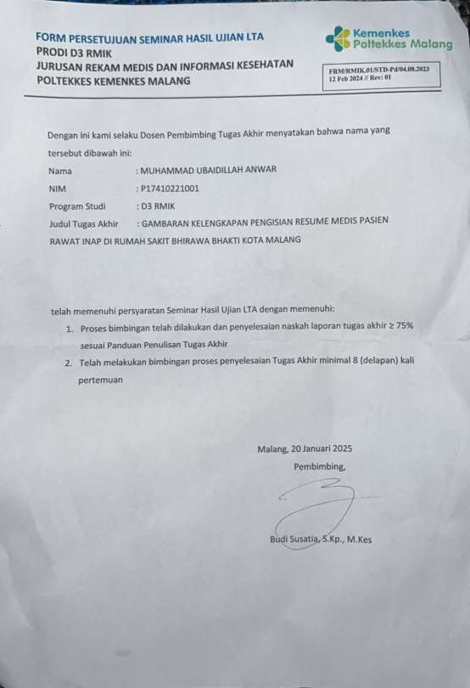

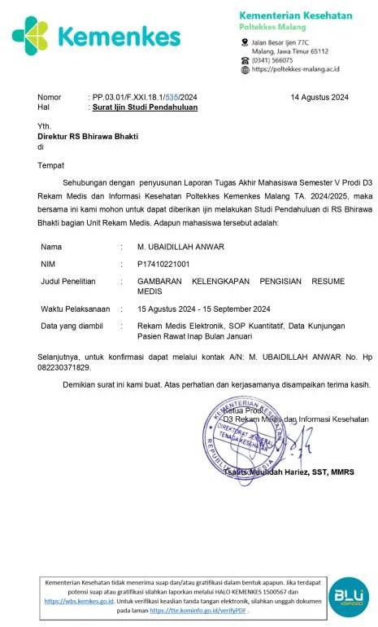
Lampiran 4 Surat Ijin Studi Pendahuluan

